Deiiang | Cleanroom World
Modular Cleanroom Solutions

MODULAR CLEANROOMS
Hardwall · Softwall · Clean Booth
Development | Production | Sales | After-sales Service

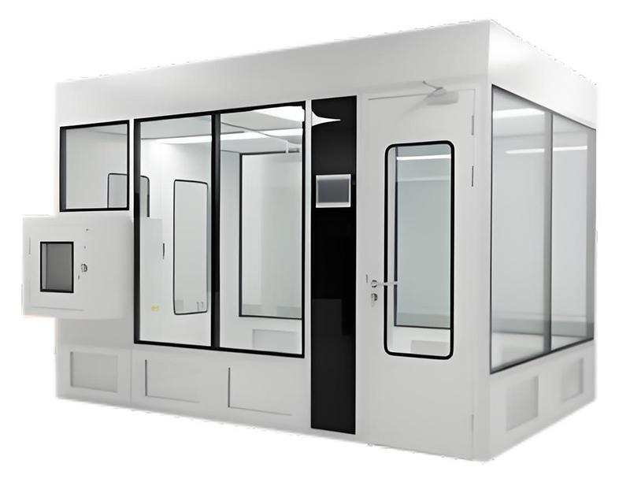

Deiiang Cleanroom Technology Co., Ltd.
B102, Building 6, Erqi Industrial Park, Jiang'an District,
Wuhan City, Hubei Province, China
Tel: +86 027 82289886 | Mobile: +86 136 3863 2902
Email: Jason@cleanroomequips.com | Web: www.cleanroomequips.com

CONTENTS
CATALOG INDEX

01 Hardwall Cleanroom
Rigid aluminum frame + panel / glass enclosure
02 Softwall Cleanroom
Aluminum frame + anti-static PVC curtain
03 Clean Booth
Localized workstation enclosure on aluminum profile
04 FFU & HEPA Platform
AC/DC fan filter units, H14/U15 filtration
05 Certifications
CE, RoHS, EN 1822, ISO 14644
06 Packing & Export
Knocked-down packing, container loading

HARDWALL CLEANROOM
RIGID MODULAR ENCLOSURE FOR LONG-TERM CLASSIFIED PRODUCTION
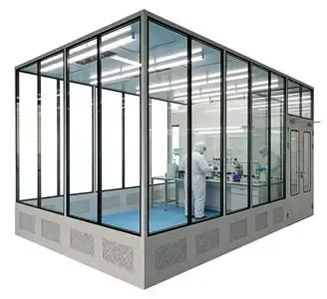
Product Description / 产品说明
■ Constructed on anodized extruded aluminum frame with sealed sandwich panel, HPL, acrylic or tempered-glass infill.
■ Suitable for ISO 5–8 per ISO 14644-1; positive or negative pressure cascade available.
■ Flush double-glazed observation windows, steel cleanroom doors with drop-down bottom seal.
■ Panels: rock-wool / glass-magnesium / paper-honeycomb / aluminum-honeycomb / PU core options.
■ HEPA H14 (EN 1822) as standard; ULPA U15/U16 option. ESD-safe conductive finish for electronics.
Product Parameters / 产品参数
Parameter / 项目 | Specification / 规格
ISO class | ISO 5 / 6 / 7 / 8 per ISO 14644-1
Airflow | Unidirectional at critical zones; turbulent for support areas
Pressure | Positive cascade 10–15 Pa; negative-pressure containment option
Filtration | G4 + F8 pre-filter + H14 HEPA; U15/U16 ULPA optional
Temperature / RH | 18–24 °C, 30–60 % RH (custom)
Frame | Anodized aluminum extrusion
Wall panels | 50 mm hand-made sandwich panel, steel skin, rock-wool / MgO / honeycomb core
Door | Steel cleanroom door, tempered-glass vision panel, auto drop-seal

 |  | 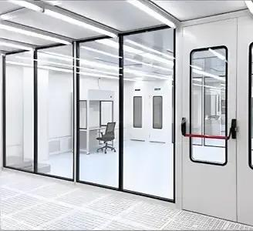 | 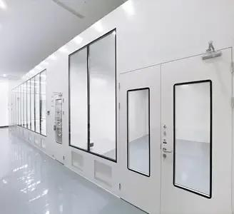

SOFTWALL CLEANROOM
FLEXIBLE PVC-CURTAIN ENCLOSURE, FAST DEPLOYMENT
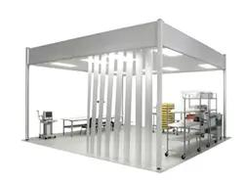
Product Description / 产品说明
■ Same aluminum frame and FFU platform as hardwall; perimeter enclosed with anti-static PVC curtains.
■ ISO 5–8 per ISO 14644-1; H14 HEPA standard; demountable and relocatable.
■ Surface resistance 10^6–10^9 Ω; cleanroom-grade, wipe-down compatible.
■ Typical installation 1–2 days on site; no wet trade; ideal for spot-cleaning around a machine.
■ Optional caster wheels for portable / temporary clean zones.
Product Parameters / 产品参数
Parameter / 项目 | Specification / 规格
ISO class | ISO 5 – ISO 8
Wall | Anti-static PVC curtain, transparent strip, surface resistance 10^6–10^9 Ω
Frame | Anodized aluminum profile, bolted, demountable
FFU | AC or energy-saving DC FFU; 575×575 / 1175×575 / 1175×1175 mm
Filtration | H14 HEPA standard; U15/U16 ULPA option
Pressure | Positive relative to workshop; negative option for local containment
Temperature / RH | 18–24 °C / 30–60 % RH with conditioned make-up air
Installation | 1–2 days standard; fully relocatable

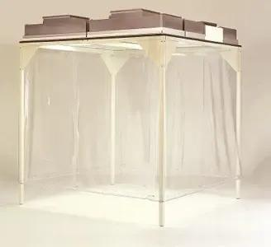 |  | 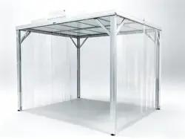 | 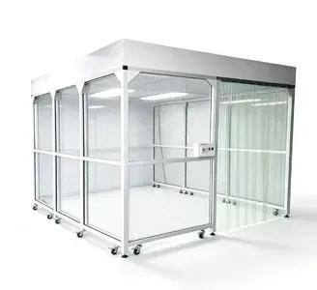

CLEAN BOOTH
LOCALIZED WORKSTATION ENCLOSURE ON INDUSTRIAL ALUMINUM PROFILE
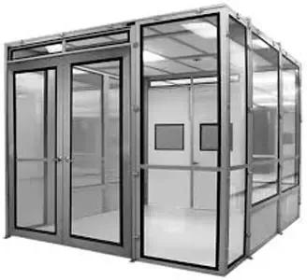
Product Description / 产品说明
■ Built on industrial aluminum extrusion (40×40 / 40×80 / 80×80 / 50×50 / 60×60 mm).
■ Infill options: clear acrylic, tempered glass, anti-static PVC curtain, or steel panel.
■ Topped by one or more FFUs with H14 HEPA / U15 ULPA; achieves ISO 5–7 at the work zone.
■ Positive or negative configuration per GMP/FDA / Risk-MaPP requirement.
■ Optional caster wheels; relocatable between production lines.
Product Parameters / 产品参数
Parameter / 项目 | Specification / 规格
Frame sections | 40×40, 40×80, 80×80, 50×50, 60×60 mm
Profile wall thickness | 1.5 / 2.0 / 2.5 / 3.0 mm
Infilling | Acrylic / tempered glass / anti-static PVC / steel panel
FFU | AC or EC/DC; 575×575 / 1175×575 / 1175×1175 mm; H14 / U15
Achievable class | ISO 1–8 by design; typically ISO 5–7 at workstation
Pressure | Positive or negative
Mobility | Optional lockable casters
Lighting | Integrated LED, sealed, local switched

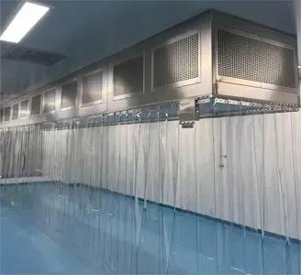 | 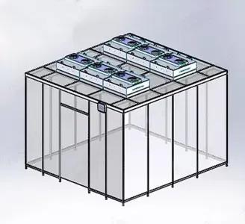 |  | 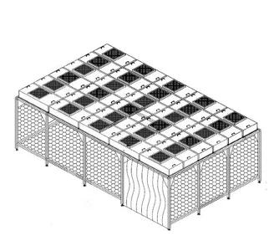

FFU & FILTRATION PLATFORM
SHARED AIR-HANDLING PLATFORM ACROSS ALL THREE PRODUCT LINES
Fan Filter Unit / 风机过滤单元
■ AC single/multi-speed FFU, or energy-saving DC (EC) fan FFU with PWM speed control.
■ Standard sizes: 575×575 mm, 1175×575 mm, 1175×1175 mm.
■ HEPA H14 per EN 1822: minimum efficiency 99.995% on MPPS; ULPA U15/U16 optional.
■ Pre-filtration: G4 intake + F8 medium filter to extend HEPA life.
■ Local speed control; optional group controller with RS-485 / Modbus, filter-dP alarm, BMS/EMS interface.
■ Typical noise < 60 dB(A) at 1 m; vibration-isolating mounting standard.
Reference ACH Ranges / 参考换气次数
ISO Class | Reference ACH range
ISO 3 | 360 – 540
ISO 4 | 300 – 540
ISO 5 | 240 – 480
ISO 6 | 50 – 60
ISO 7 | 30 – 40
ISO 8 | 15 – 25

CERTIFICATIONS
DOCUMENTS SUPPLIED WITH EXPORT ORDERS
Available Certifications / 可提供证书
■ CE Declaration of Conformity for FFU / electrical control panel (EMC + LVD directives).
■ RoHS test report for FFU and control components (TÜV SÜD tested).
■ HEPA/ULPA filter test certificates per EN 1822-1 / -2 / -4 (per-filter scan).
■ ISO 16890:2022 classification report for outdoor-air intake pre-filters.
■ ISO 14644-1 at-rest classification test report (after installation, by Deiiang or third party).
■ Material certificates: panel coating, aluminum alloy, EPDM/silicone gasket, anti-static PVC.
■ Fire-rating declaration for rock-wool / MgO core panels.
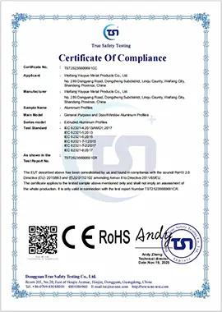
Example: TÜV SÜD CE / RoHS compliance certificate for Deiiang FFU control panels

PACKING & EXPORT
KNOCKED-DOWN, CONTAINER-OPTIMISED EXPORT PACKING
Packing Details / 包装明细
■ Aluminum profiles: PE film wrap, strapped on plywood pallets, labelled by part number.
■ Sandwich panels: edge-protected, flat-packed in plywood crates, EPE-foam separated.
■ FFUs: double-wall carton with foam corners; HEPA element sealed in plastic; one unit per carton.
■ Doors & windows: edge-protected, carton + plywood frame, glass side marked 'FRAGILE — THIS SIDE UP'.
■ Electrical panels: sealed carton with desiccant, palettised.
■ Hardware kit: one labelled accessory box per room (fasteners, gaskets, hinges, cables).
■ Documentation pouch on lead package: packing list, commercial invoice, CE DoC, filter certificates, as-built drawings, installation manual, test-report templates.
Container Loading / 集装箱装载
■ Typical 40'HQ carries approx. 80–120 m² hardwall panel face area + associated FFUs and doors.
■ Incoterms: EXW / FOB Shenzhen standard; CIF Hamburg / Bremerhaven available on request.
Information Required for Firm Quotation / 询价所需资料
■ Product and process: sterile vs non-sterile; any potent / cytotoxic dust.
■ Room schedule: name, dimensions (L×W×H), required ISO class per room.
■ Site conditions: supply voltage (400 V 3Ph 50 Hz), floor load, ceiling height, door size.
■ Documentation expectations: third-party certificates and on-site qualification support.
■ Target delivery date and preferred Incoterm.

Deiiang Cleanroom Technology Co., Ltd.
B102, Building 6, Erqi Industrial Park, Jiang'an District, Wuhan, Hubei, China
Tel: +86 027 82289886 Mobile: +86 136 3863 2902
Email: Jason@cleanroomequips.com Web: www.cleanroomequips.com

